ALL RIDING BOOTS WILL HAVE THE BLACK ROUGH VIBRAM SOLE
OR A DIFFERENT STYLE AT REQUEST
ALL SNEAKERS WILL HAVE VIBRAM SNEAKER SOLE
OR A DIFFERENT STYLE AT REQUEST
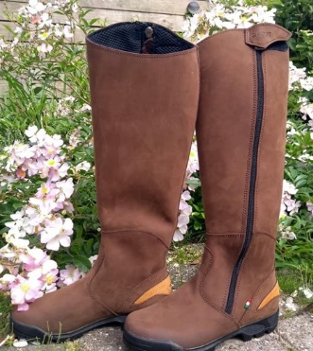
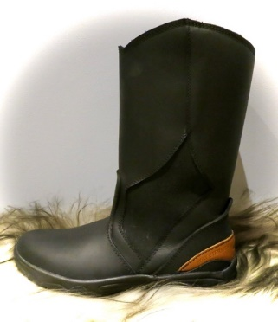
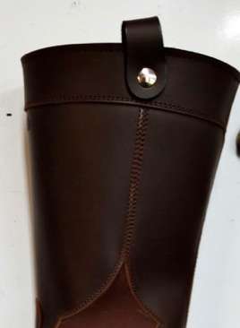
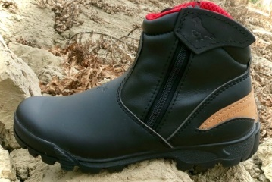
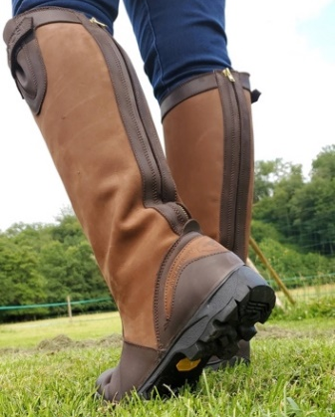

- Standard material is oiled nubuck or micropell/micronappa for those who prefer synthetic materials.
- Julia and Nappa leathers are extra - $35
- Protective Steel Toe is optional for boot models - $35
- The difference between Ranch and Sentiro boots are the topline – curved for Ranch and straight for Sentiero
- Sizes are available in European 35-47

SOLE OPTIONS:
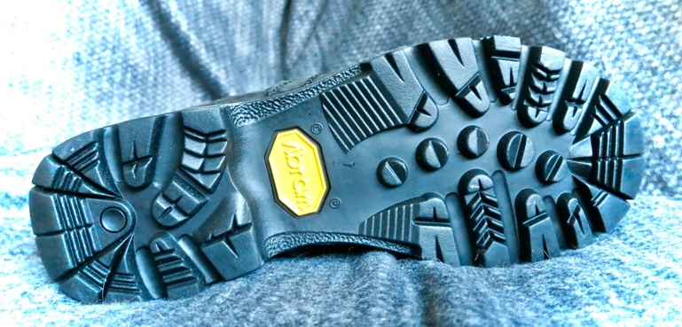 | 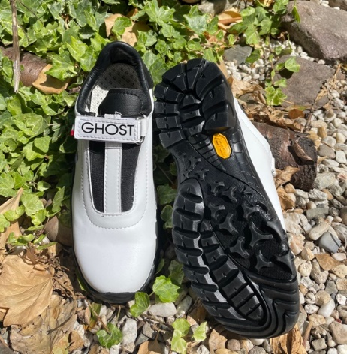
Vibram full grip | Vibram Viking
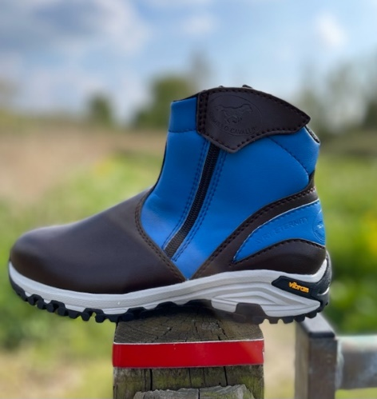 | 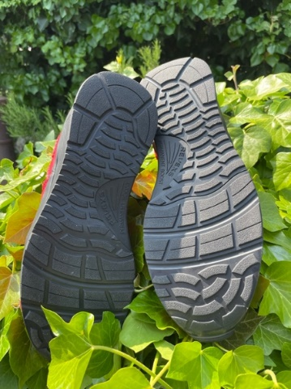
Vibram sneaker sole | Revexs: +$20

BOOT STYLES:
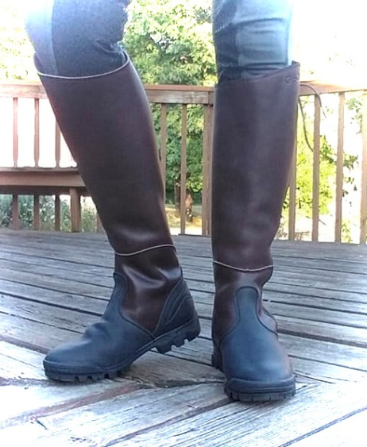 | 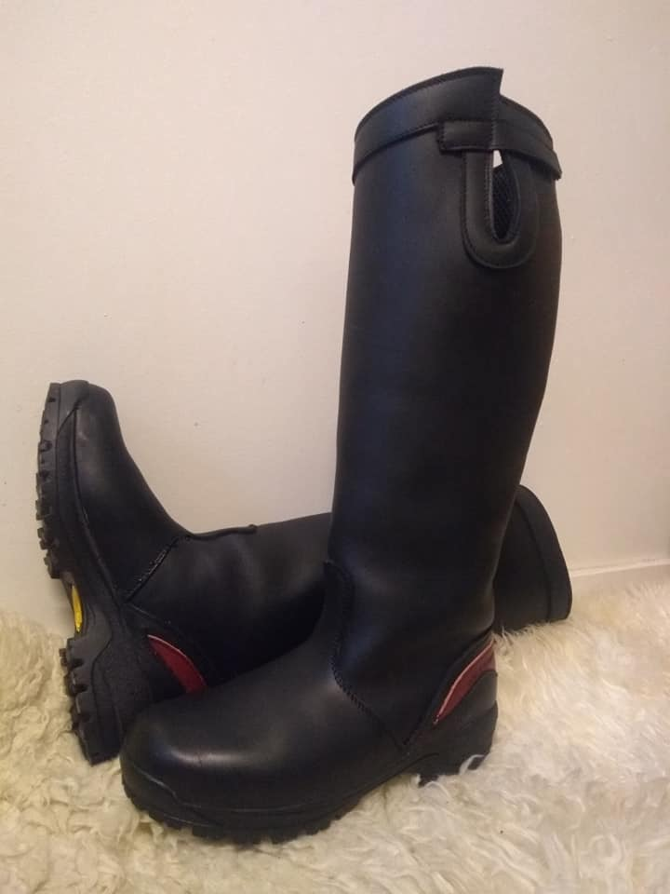 | 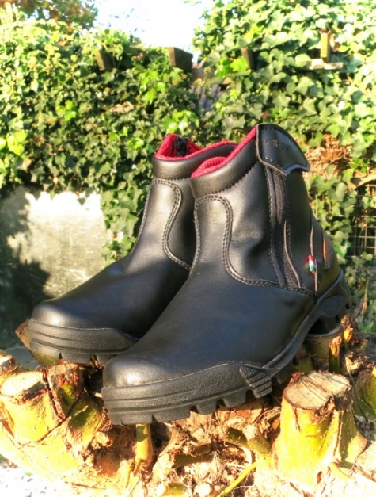
Stelvio – Tall boot ($250) | Terra – Tall ranch boot ($250) | Fantino - Paddock boot ($175)
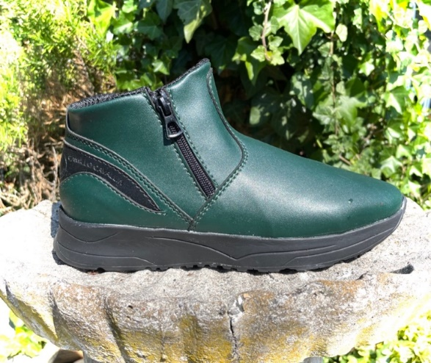 | 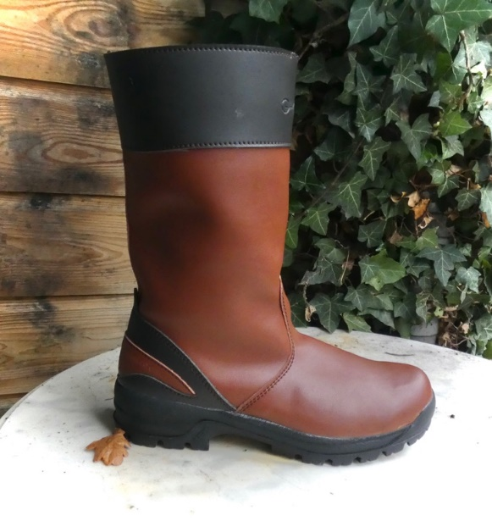 | 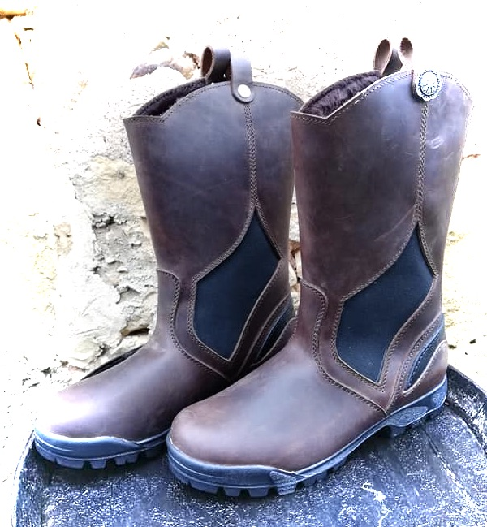
Fantina – Low paddock boot ($150) | Sentiero – Outdoor boot ($200) | Ranch – USA boot ($200)

SNEAKER STYLES:
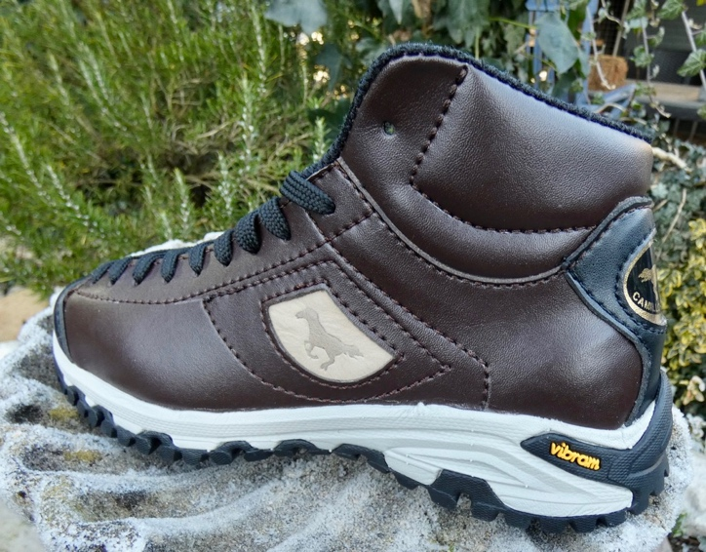 | 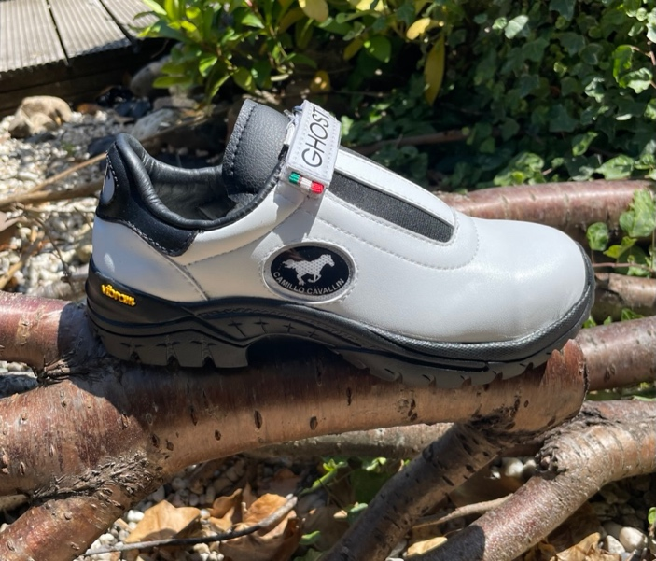
Bolzano – High sneaker ($150) | Endurance sneaker – low ($120)
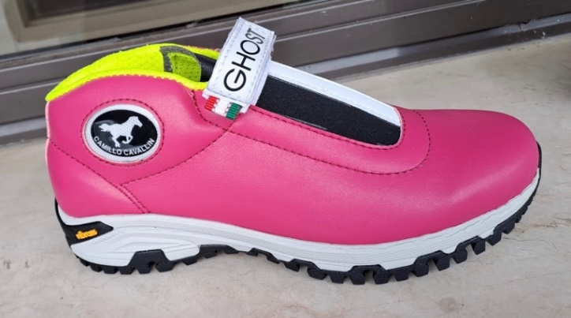 | 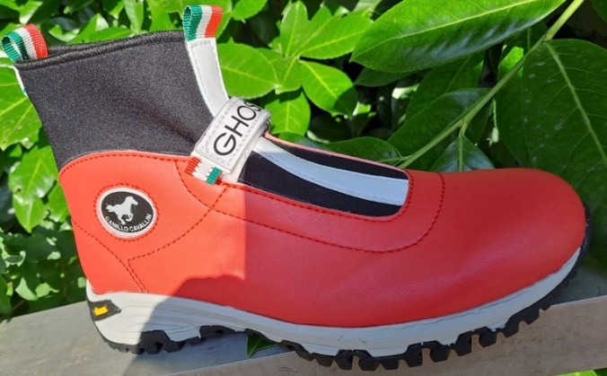
Endurance sneaker – medium ($130) | Endurance sneaker – high with Velcro ($150)
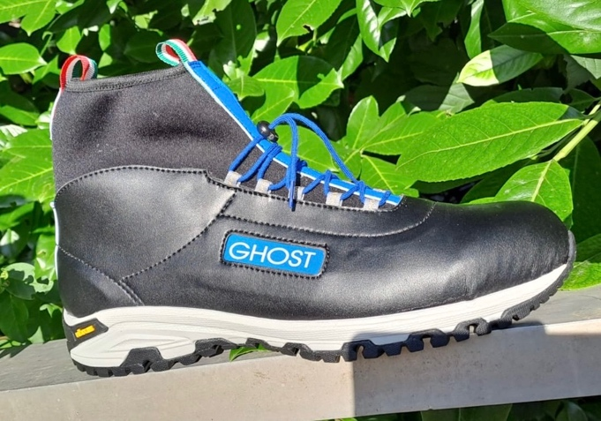 | 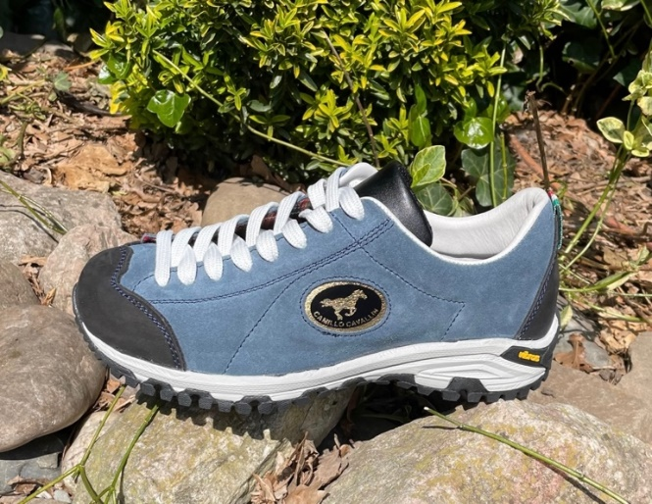
Endurance sneaker – high with laces ($150) | Trento – sneakers ($120)

